**Relational Database Service:**

* We can store the structured data like table format in database.
* We can easily identify the particular user data in database.

**Types:**

* **SQL**
* **NOSQL**

**SQL :**

There different types of databases.

* Mysql
* Postgresql
* Aurora
* Oracle

**Steps to create MYSQL Database:**

* Go to RDS service and click on create database.
* Select standard create option and select the mysql
* Select free tier option for practice and enter name of database.
* Enter user name and password and select vpc and two subnets in two different availability zones.
* Choose security group and select no option for public access.
* Click on create database.
* Connect to the ec2 instance after creating database.

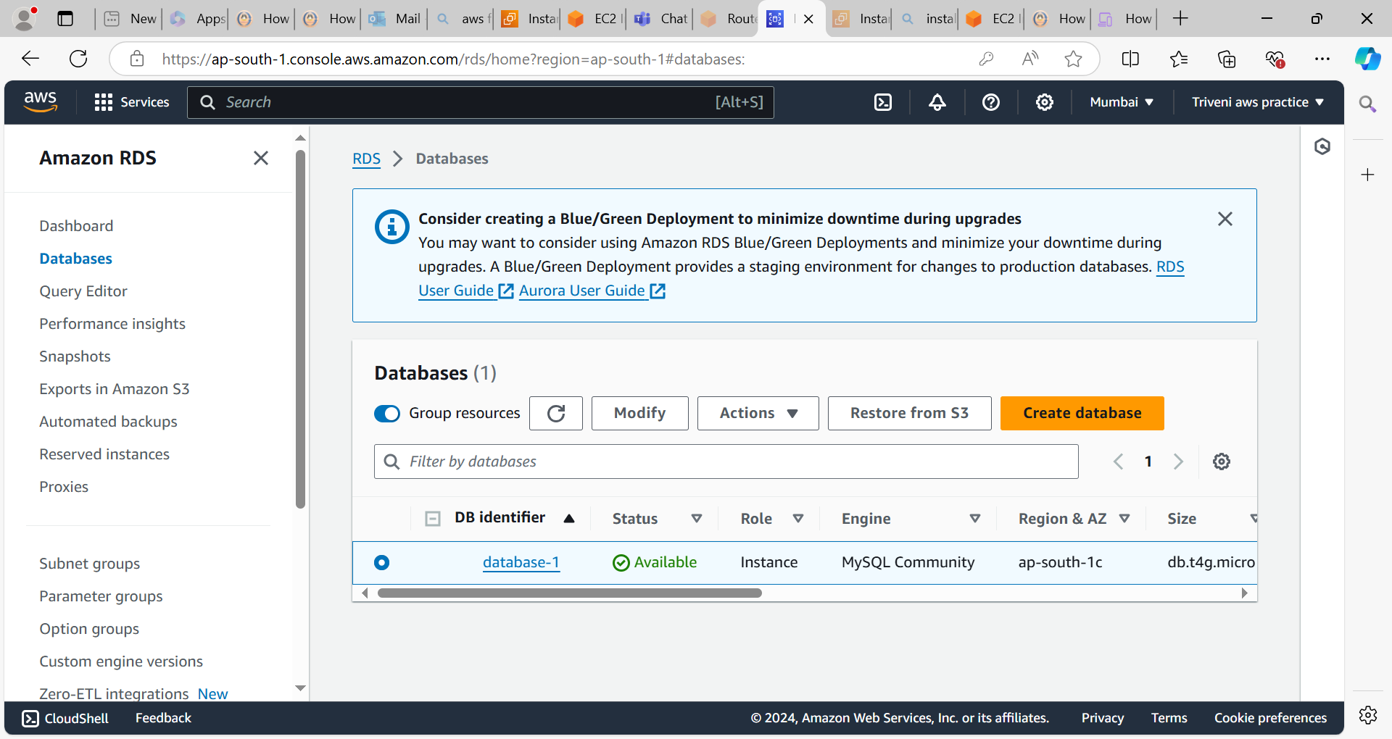

**EC2 Instance:**

* Create amazon linux instance and install the mysql on this server.

Link for installation process of mysql on amazon linux

<https://www.appsdeveloperblog.com/how-to-install-mysql-on-amazon-ec2-linux>

[How To Install MySQL 8 on Amazon Linux 2 – TecAdmin](https://tecadmin.net/how-to-install-mysql-8-on-amazon-linux-2/)

* After installation login to the mysql by using commands.

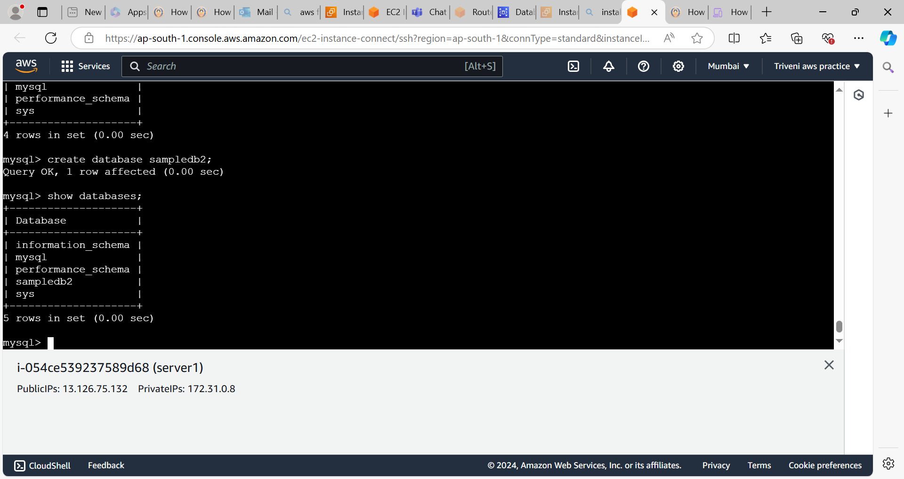

Install the mysql on ubuntu server

Link for installation mysql on ubuntu

[How to Install MySQL Server on Ubuntu 24.04 – TecAdmin](https://tecadmin.net/how-to-install-mysql-server-on-ubuntu-24-04/)

